Republic of the Philippines Bicol University



**POLANGUI CAMPUS**

Polangui, Albay [www.bupolangui.com](http://www.bupolangui.com/)

# **SOFTWARE DESIGN**

# **Midterm Laboratory Exam**

MARICON T . SAUNAR

BSCPE-2A

**E-Commerce Website Project**

Website Name:

C++ (Coffee Plus Plus)

**MODULE 3: Product Search Bar Optimization System**

A Product Search Bar Optimization System is a vital tool for e-commerce websites that enables users to search for products quickly and easily. By implementing advanced algorithms and techniques, the system enhances the accuracy of search results, provides relevant product recommendations, and tracks user behavior. This data can then be used to improve the website’s product catalog, descriptions, and even add new products. The optimization of the search bar leads to increased customer satisfaction, repeat purchases, and higher revenue for the business.

This system would help to optimize the website for search engines, making it easier for potential customers to find the website and its products.

1. 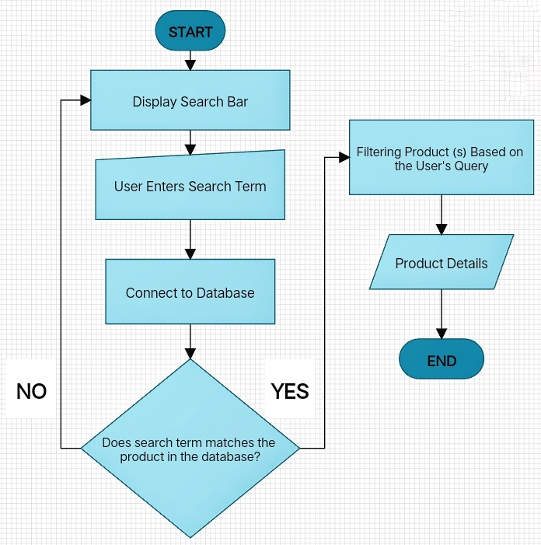**FLOWCHART**

The flowchart begins by presenting a search bar to the user, allowing them to enter their desired search term. The input is then processed by the search bar system and connected to the product catalog database of the e-commerce website.

The system then conducts a search of the product catalog based on the user’s search term, followed by a decision point to determine if the search term matches any of the products in the database. If there is no match, the system will return to displaying the search bar. However, if there is a match, the system will filter the products based on the user’s search term.

The system will then present the user with a list of coffees that match their search term, along with pertinent information such as the coffee’s name, image, price, and a brief description. The user can access more information about a specific coffee by clicking on its listing.

1. **HIPO**

HIPO (Hierarchy Input-Process-Output) is a structured approach to define and document the functionalities of a system.

Here is the HIPO for the Product Search Bar Optimization System of our e-commerce website project:

**HIERARCHY DIAGRAM**

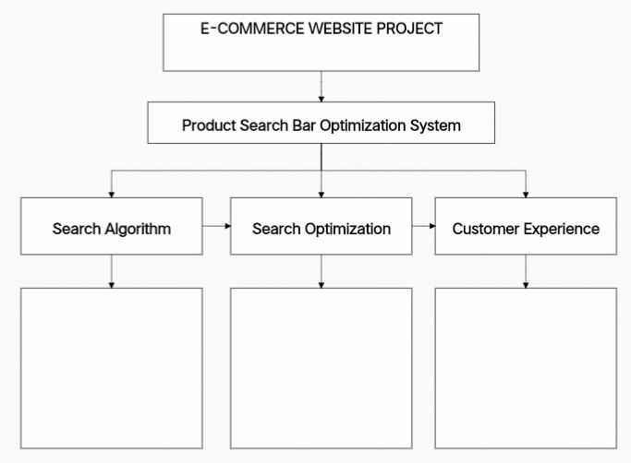

E-COMMERCE WEBSITE

Coffee Plus Plus

Provide real-time search suggestions

Show results preview

Optimize search results

Provide filters and sorting options

Implement search algorithm

**INPUT – PROCESS – OUTPUT**

**OUTPUT**

* A list of coffees that match the user’s search query and any additional parameters.
* Each product listing will include relevant details such as coffee name, image, price, and a brief description.
* The user will be able to view additional coffee details by clicking on a specific product listing.
* The user will be able to refine their search results further by selecting additional sorting or filtering options, or by modifying their search query.

**PROCESS**

* The search bar system will process the user’s search query and any additional parameters to determine the appropriate search algorithm.
* The system will search the e-commerce website’s product catalog for coffee(s) that match the user’s query and parameters.
* The system will apply any sorting or filtering options selected by the user, such as sorting by price, size, or coffee’s category.

**INPUT**

* User’s search query (e.g., “Americano”, “ Iced Tea”)
* Additional search parameters, such as product category, price range, size, etc.

The search bar system takes a user’s search query and any additional search parameters, and searches an e-commerce website’s product catalog for coffee products that match the input. The system then applies any sorting or filtering options selected by the user, such as sorting by price, size, or coffee category, and displays a list of matching coffees. Each coffee listing includes relevant details such as the coffee’s name, image, price, and a brief description. The user can view additional coffee details by clicking on a specific listing and can further refine their search results by selecting additional sorting or filtering options or modifying their search query.

Overall, this HIPO would help ensure that our e-commerce website’s product search bar functions correctly and efficiently, providing a seamless user experience.

1. **DECISION TABLE**

This decision table describes the conditions and actions for three different users when interacting with a system that involves inputting a product name.

The first row of conditions indicates whether each user has inputted a product name. The second row indicates whether the inputted product name matches an existing product name in the system. The third row indicates whether the inputted product name contains only valid characters.

The first row of actions indicates whether the system should show a matched product to the user. The second row indicates whether the system should show an empty page to the user. The third row indicates whether the system should do nothing.

According to this table:

* User 1 has inputted a product name with valid characters but it does not match any existing product names in the system. As a result, the system will show an empty page to User 1.
* User 2 has not inputted a product name and as such, no action is taken by the system for User 2.
* User 3 has also not inputted a product name and as such, no action is taken by the system for User 3.

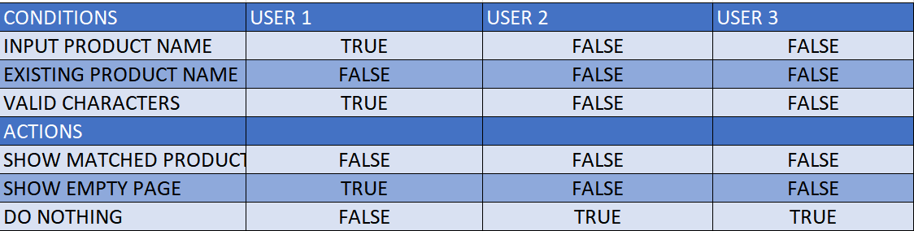

1. **DATA DICTIONARY**

This data dictionary describes the attributes of a Product Search Bar System. The system stores information about various products, and the data dictionary provides a detailed description of the attributes of each product.

* The first attribute is product_ID, which is an integer data type with a length of 10. It is marked as primary, which means that it serves as the unique identifier for each product in the system.
* The product_name attribute is a varchar data type with a length of 50, and it cannot be null. It represents the name of the product.
* The product_time attribute is an integer data type with a length of 50, and it cannot be null. It represents the production time of the product.
* The product_calories attribute is a varchar data type with a length of 10, and it cannot be null. It represents the number of calories contained in the product.
* The product_price attribute is an integer data type with a length of 50, and it cannot be null. It represents the price of the product.
* The product_description attribute is a text data type with a length of 50, and it cannot be null. It represents a description of the product.
* The last attribute, product_image, is an image/PNG data type and cannot be null. It represents an uploaded image file of the product in the database.

Overall, this data dictionary provides a detailed description of the product search bar system’s attributes, which can help users understand the system’s functionality and usage.

|  |  |  |  |  |
| --- | --- | --- | --- | --- |
| Field Name | Data Type | Length | Constraints | Description |
| product_ID | Integer | 10 | Primary | Unique identifier for each product in the system |
| product_name | Varchar | 50 | Not null | The name of the product |
| product_time | Integer | 50 | Not null | Production time of the product |
| product_calories | Varchar | 10 | Not null | The number calories contained in the product |
| product_price | Integer | 50 | Not null | The price of the product |
| product_description | Text | 50 | Not null | A description of the product |
| product_image | Image/PNG |  | Not null | An uploaded image file of the product in the database |

1. **DATA FLOW DIAGRAM**

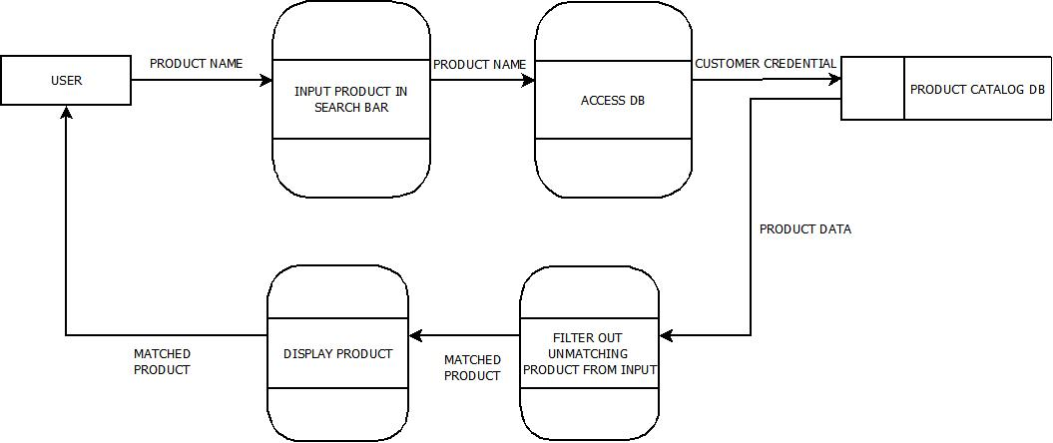This dataflow diagram illustrates the process that occurs when a user queries a specific product name in the search bar of a coffee shop's website. The query is sent to an access data process, which filters out any unmatching products based on the input given by the user. Once a matching product is identified, it is then displayed on the website for the user to view. This process ensures that users are able to easily find the product they are looking for with minimal effort.